ADITHYA R
192311369

23.Demonstrate Storage as a Service (SaaS) create and configure a new VM Image in any Public Cloud Service Provider using Azure.
AIM: To demonstrate Storage as a Service by creating and configuring an Azure Storage Account and uploading data using Microsoft Azure
Procedure:
STEP 1: Login to Azure Portal
- Open browser
- Go to https://portal.azure.com
- Login with Azure credentials

STEP 2: Create Resource Group
- Search Resource Groups
- Click Create
- Enter:
  - Resource Group Name: Storage-Demo-RG
  - Region: Central India (or nearest)
- Click Review + Create → Create

STEP 3: Create Storage Account
- Click Create a Resource
- Search Storage Account
- Click Create
Fill in details:
- Resource Group: Storage-Demo-RG
- Storage Account Name: storagedemo123 (must be unique)
- Region: Same as Resource Group
- Performance: Standard
- Redundancy: Locally Redundant Storage (LRS)
Click Review + Create → Create
⏳ Deployment takes 1–2 minutes.

STEP 4: Create a Blob Container
- Go to Storage Account
- Click Containers
- Click + Container
- Name: demo-container
- Public Access Level: Private
- Click Create

STEP 5: Upload File to Cloud Storage
- Open demo-container
- Click Upload
- Select any file (e.g., text/image/pdf)
- Click Upload
File is now stored in Azure Cloud.

STEP 6: Access the File
Click the uploaded file → Copy URL
Example format:
https://storagedemo123.blob.core.windows.net/demo-container/file.txt

ARCHITECTURE
User → Azure Storage Service → Azure Data Center
Azure manages:
- Physical disks
- Replication
- Security
- Scalability
User manages:
- Files and access permissions

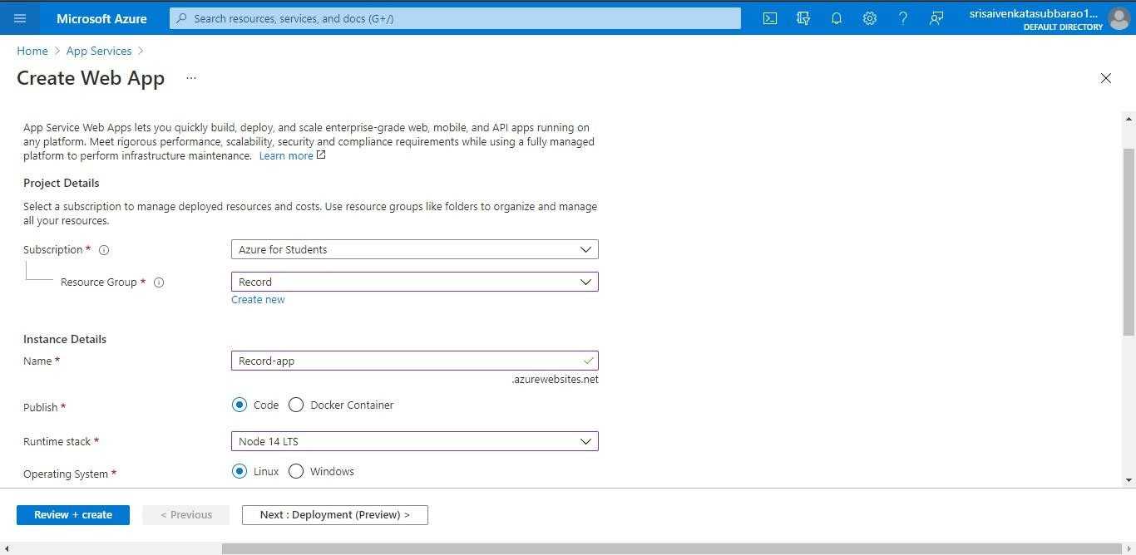

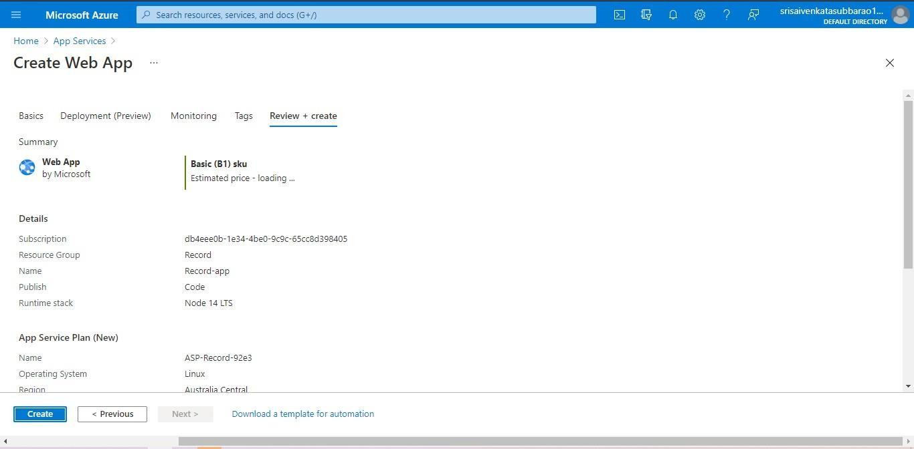

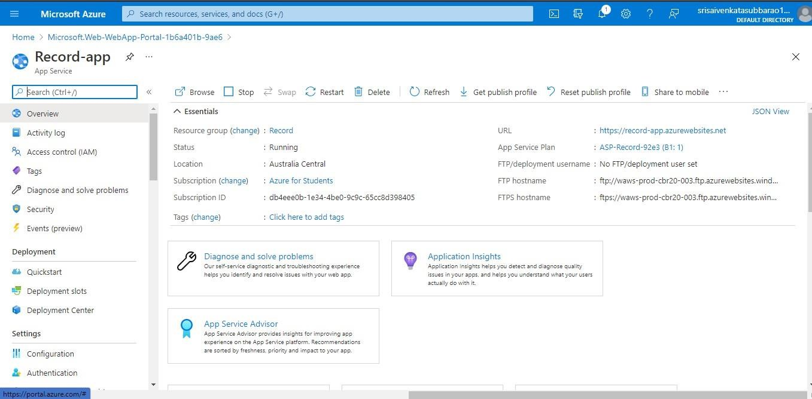

RESULT: The Azure Storage Account was successfully created and configured.
A Blob container was created and files were uploaded successfully.
Thus, Storage as a Service was successfully demonstrated using Microsoft Azure.

